Kappa Score
https://towardsdatascience.com/multi-class-metrics-made-simple-the-kappa-score-aka-cohens-kappa-coefficient-bdea137af09c
kappa score considers how much better the agreements are over and beyond chance agreements.It basically tells you how much better your classifier is performing over the performance of a classifier that simply guesses at random according to the frequency of each class.
KappaScore=(Agree-ChanceAgree)/(1-ChanceAgree)
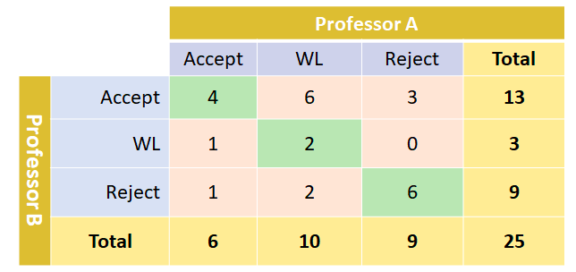
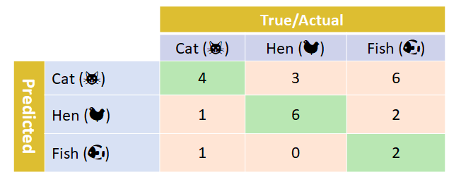

ProbA(Accept) = 6/25=0.24
ProbB(Accept)=13/25=0.52
ChanceAgree(Accept)=ProbA(Accept) × ProbB(Accept)=0.24×0.52=0.1248
ProbA(WL)=10/25=0.4
ProbB(WL)=3/25=0.12
ChanceAgree(WL)=ProbA(WL)×ProbB(WL)=0.4×0.12=0.048
ProbA(Reject)=9/25=0.36
ProbB(Reject)=9/25=0.36
ChanceAgree(Reject)=ProbA(Reject)×ProbB(Reject)=0.36×0.36=0.1188
ChanceAgree=
= ChanceAgree(Accept)+ChanceAgree(WL)+ChanceAgree(Reject)
= 0.1248+0.0480+0.1188=0.3024
KappaScore = (Agree-ChanceAgree)/(1-ChanceAgree)
= (0.48–0.3024)/(1–0.3024)
= 0.2546
If Agree=1, we have perfect agreement, corresponding to a matrix where all the non-diagonal (pink) cells are 0. In this case, the kappa score is 1, regardless of ChanceAgree. In contrast, if Agree=ChanceAgree, kappa is 0, signifying that the professors’ agreement is by chance. If Agree is smaller than ChanceAgree, the kappa score is negative, denoting that the degree of agreement is lower than chance agreement.
According to their scheme a value < 0 is indicating no agreement , 0–0.20 as slight, 0.21–0.40 as fair, 0.41–0.60 as moderate, 0.61–0.80 as substantial, and 0.81–1 as almost perfect agreement.

ASGI vs WSGI
https://www.technoarchsoftwares.com/blog/asgi/
ASGI stands for Asynchronous Server Gateway Interface
WSGI stands for Web Server Gateway Interface
When the relatively new protocols other than standard HTTP (HyperText Transfer Protocol) especially WebSocket started gaining popularity within the web developers community, WSGI failed to provide a way to develop applications which can handle these protocols.
ASGI:
A connection scope, which represents a protocol connection to a user and lasts the lifetime of that connection.
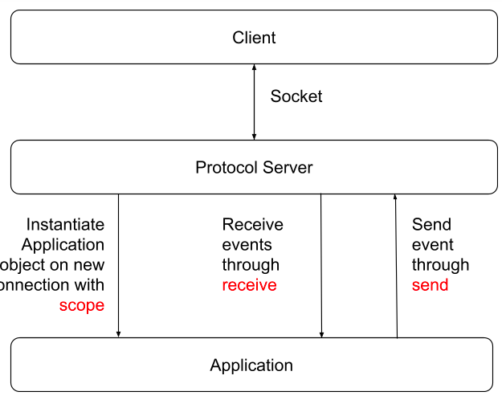
Events, which are sent to the application when anything happens on that connection.

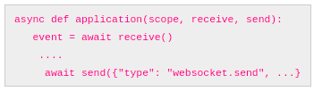

Flask vs Django
Flask provides support for API while Django doesn't have any support for API.
Flask does not support dynamic HTML pages and Django offers dynamic HTML pages.
Flask is a Python web framework built for rapid development whereas Django is built for easy and simple projects.
Flask offers a diversified working style while Django offers a Monolithic working style.
URL dispatcher of the Flask web framework is a RESTful request on the other hand, URL dispatcher of Django framework is based on controller-regex.
Flask is WSGI framework while Django is a Full Stack Web Framework.

